The level of risk premium is measured by credit spreads – the difference in yields between various private debt instruments and government securities of comparable maturity. Gilchrist and Zakrajsek (2012) constructed a new credit spread index called “GZ credit spread” employing secondary market prices of outstanding senior unsecured bonds issued by a large panel of US nonfinancial corporations. They showed that it has considerable predictive power for economic activity over 1973 to 2010 period, compared with other popular default-risk indicators like Baa-Aaa spread (the spread between the yields on Baa- and Aaa-rated long-term industrial corporate bonds) and CP-Bill spread (the spread between the yield on one-month A1/P1 nonfinancial commercial paper and the one-month US Treasury yield). See Figure 1.

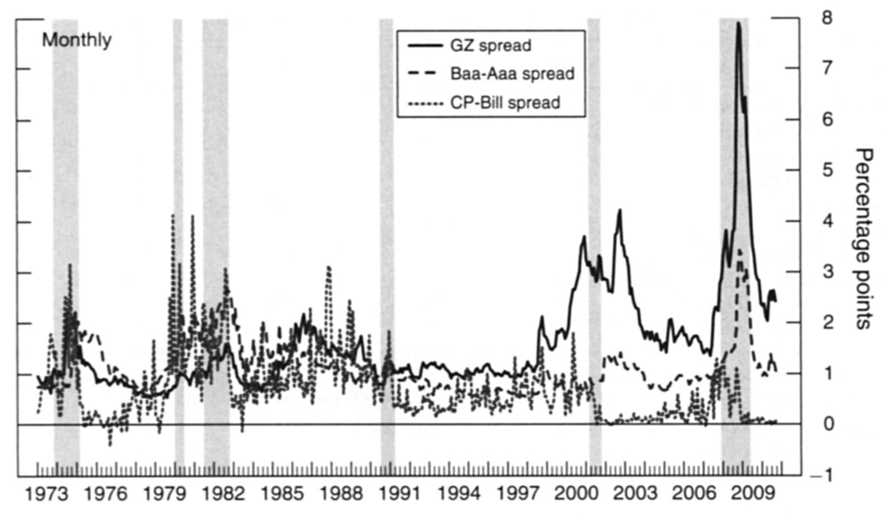

Figure 1. Selected Corporate Credit Spreads. The shaded vertical bars represent the NBER-dated recessions.

Additionally, Gilchrist and Zakrajsek (2012) decomposed GZ credit spread into a component reflecting firm-specific default risk and a residual component they called “the excess bond premium”. Over the 1985-2010 period, the excess bond premium accounts for most of the predictive power of the GZ credit spread on economic output growth.

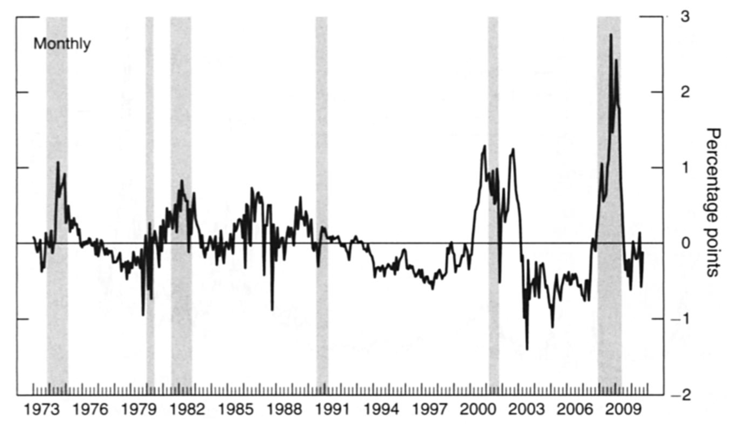

Figure 2. The Excess Bond Premium. The shaded vertical bars represent the NBER-dated recessions.